CREATE MAVEN PROJECT:  
Step1:

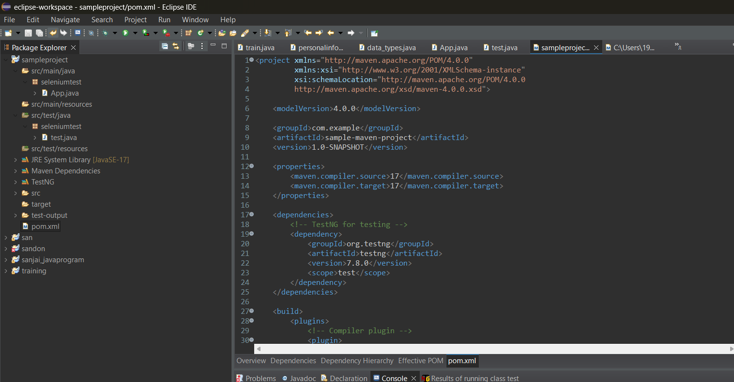

Step2:Push it to github

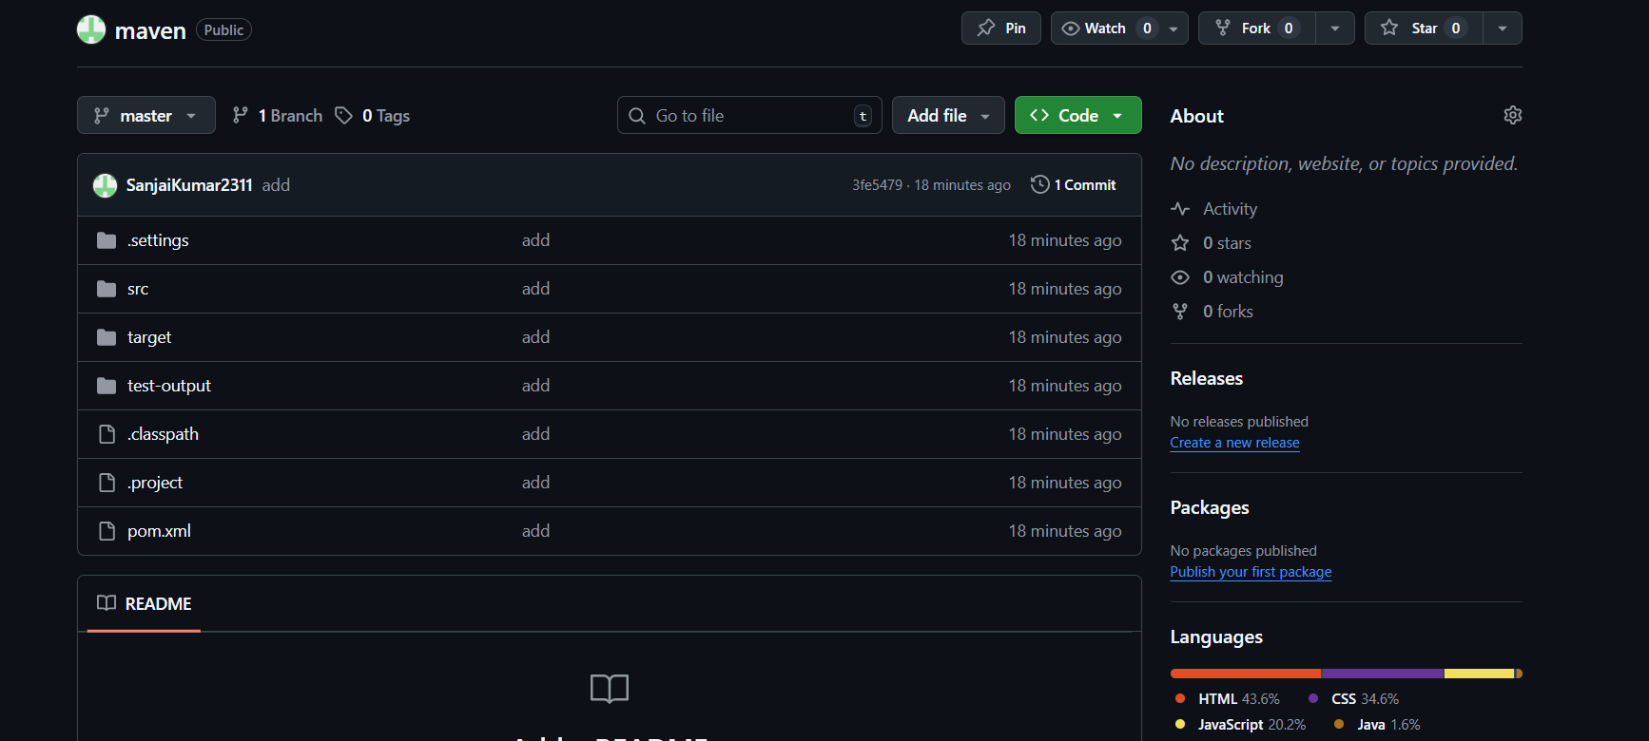

Step3:

Push the code using github into jenkins and do testng using pom.xml

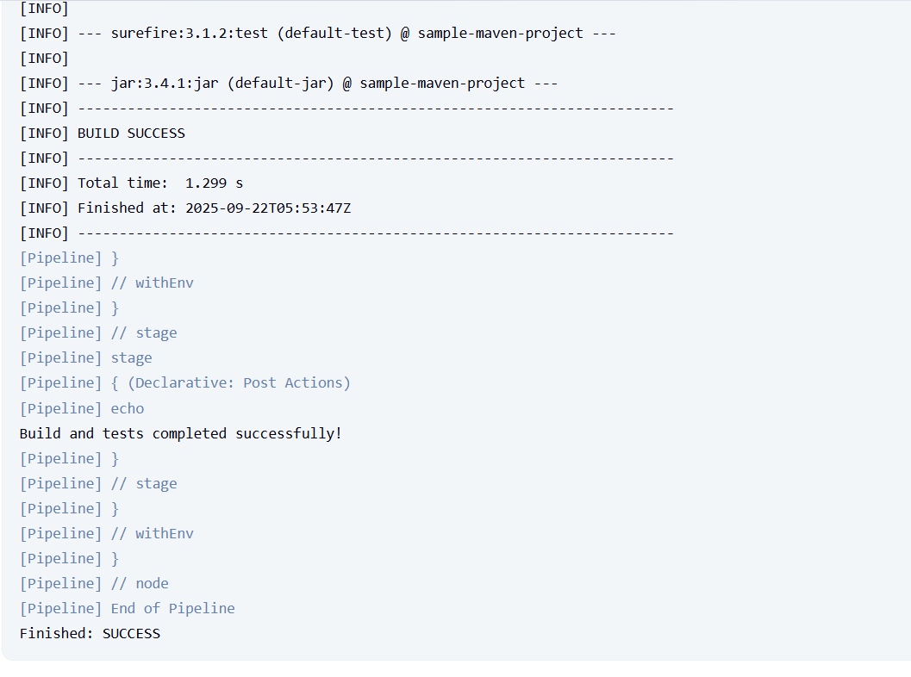

Step 4:  
put jira for the above   
epic:maven project  
story:push to git  
task:run in jenkins  
subtask:success or failure

